**CHATBOT USING PYTHON**

***Social relevant project report submitted in partial fulfilment of the requirements for the award of degree***

**BACHELOR OF TECHNOLOGY**

**IN**

**COMPUTER SCIENCE AND ENGINEERING**

**Submitted by**

**J.R.SAILOHITHA 19KA1A0519**

**G.MANISHA 19KA1A0505**

**A.REDDYHEMA 19KA1A0526**

**A.JAYANTHI 19KA1A0508**

**CH.MOUNIKA 20KA5A0504**

**Y.SUPRIYA 19KA1A0543**

**Under the esteemed guidance of**

**Dr. SHAIK NASEERA B.E, MTech,Ph.D**

**Professor & Head Of the Department**

**Department of CSE**



**DEPARTMENT OF COMPUTER SCIENCE AND ENGINEERING**

**JAWAHARLAL NEHRU TECHNOLOGICAL UNIVERSITY ANANTAPUR**

**COLLEGE OF ENGINEERING KALIKIRI**

**CHITTOOR DISTRICT, ANDHRAPRADESH – 517234**

**2021-2022**

**JAWAHARLAL NEHRU TECHNOLOGICAL UNIVERSITY ANANTAPUR**

**COLLEGE OF ENGINEERING KALIKIRI**

DEPARTMENT OF COMPUTER SCIENCE AND ENGINEERING



**CERTIFICATE**

*This is to certify that the project report entitled “****CHATBOT USING PYTHON PROGRAMMING****” that is submitted by*

**JANGALA RAMU SAILOHITHA 19KA1A0519**

**GUDITI MANISHA 19KA1A0505**

**AVULA REDDYHEMA 19KA1A0526**

**ATHIPATI JAYANTHI 19KA1A0508**

**CHINTHAREDDY MOUNIKA 20KA5A0504**

**YEGGONU SUPRIYA 19KA1A0543**

in partial fulfilment of the requirements for the award of degree of Bachelor of Technology (B.Tech) **in Computer Science and Engineering (CSE)** from **Jawaharlal Nehru Technological University Anantapur College of Engineering, Kalikiri** during the academic year 2021-2022.

**Project Guide Head of the Department**

**Dr. SHAIK NASEERA MTech., Ph.D , Dr. SHAIK NASEERA,MTech.,Ph.D,**

**Professor & Head of Department, Professor & Head of Department,**

**Department of CSE, Department of CSE,**

**JNTUACE Kalikiri, JNTUACE Kalikiri,**

**Chittoor (Dist). Chittoor (Dist).**

**JAWAHARLAL NEHRU TECHNOLOGICAL UNIVERSITY ANANTAPUR**

**COLLEGE OF ENGINEERING, KALIKIRI**

DEPARTMENT OF COMPUTER SCIENCE AND ENGINEERING



**DECLARATION**

We,SAILOHITHA(19KA1A0519),G.MANISHA(19KA1A0505),A.REDDYHEMA(19KA1A0526),A.JAYANTHI(19KA1A0508),CH.MOUNIKA(20KA5A0504),Y.SUPRIYA(19KA1A0543) hereby declare that the project work entitled “**CHATBOT USING PYTHON PROGRAMMING**” is a genuine work carried out by us under the guidance of **Prof Shaik Naseera ,B.E,M.Tech,Ph.D ,Professor & Head Of The Department of CSE Department**, in partial fulfilment for award of degree of “**BACHELOR OF TECHNOLOGY**” from JNT University, Anantapur.

The results embodied in this project work has not been submitted to any other university or institute for the award of any degree.

**JANGALA RAMU SAILOHITHA 19KA1A0519**

**GUDITI MANISHA 19KA1A0505**

**AVULA REDDYHEMA 19KA1A0526**

**ATHIPATI JAYANTHI 19KA1A0508**

**MOUNIKA CHINTHAREDDY 20KA5A0504**

**YEGGONU SUPRIYA 19KA1A0543**

**ACKNOWLEDGEMENTS**

An endeavour over a long period can be successful only with advice and support of many well-wishers. The task would be incomplete without mentioning the people who have made it possible, because is the epitome of hard work. So, with the gratitude, we acknowledge all those whose guidance and encouragement owned our efforts with success.

We are thankful to our principal **Dr. M.L.S. DEVA KUMAR, MTech., Ph.D.,** for his kind and timely help offered to us in projection of our studies and execution.

We are very much obliged to our beloved **Dr. SHAIK NASEERA, MTech., Ph.D., HOD and Professor,** Department of Computer Science & Engineering, JNTUACE, Kalikiri for the moral support and invaluable advice provided by her for the success of the project.

We wish to express grateful acknowledgement to our guide **Dr. SHAIK NASEERA, MTech., Ph.D., HOD and Professor,** CSE Department, JNTUACE, Kalikiri, for his inspiring guidance and continuous encouragement throughout the project and for his kind and timely help offered to us in projection of our studies and execution and provided us all required facilities and helped in accomplishing the project within time.

Finally, we would like to extend our deep sense of gratitude to all the staff members, friends and last but not least we are greatly indebted to our parents who inspired us at all circumstances.

**PROJECT ASSOCIATES**

**JANGALA RAMU SAILOHITHA 19KA1A0519**

**GUDITI MANISHA 19KA1A0505**

**AVULA REDDYHEMA 19KA1A0526**

**ATHIPATI JAYANTHI 19KA1A0508**

**MOUNIKA CHINTHAREDDY 20KA5A0504**

**YEGGONU SUPRIYA 19KA1A0543**

**ABSTRACT**

A chatbot is a computer software program that conducts a conversation via auditory or textual methods. This software is used to perform tasks such as quickly responding to users, informing them, helping to purchase products and

providing better service to customers. Chatbots are programs that work on Artificial Intelligence (AI) & Machine Learning Platform. Chatbot has become more popular in business groups right now as it can reduce customer service costs and handles multiple users at a time. But yet to accomplish many tasks there is a need to make chatbots as efficient as possible. In this project, we provide the design of a chatbot, which provides a genuine and accurate answer for any query using Artificial Intelligence Markup Language (AIML) and Latent Semantic Analysis (LSA) with python platform

**LIST OF CONTENTS**

|  |  |  |
| --- | --- | --- |
| **CHAPTER** | **TITLE** | **PAGE NO.** |
| **I**  1.1 | **INTRODUCTION**  About the Project | 1-2 |
| II  2.1  2.2  2.3  2.4  2.5  2.6 | **SYSTEM ANALYSIS**  Existing System  Disadvantages of Existing System  Proposed System  Advantages of Proposed System  Hardware and Software Specification  Feasibility Study | 3  3  3  4  4  4-6 |
| **III**  3.1  3.2 | **SYSTEM DESIGN**  Modules Description  UML Diagrams and Block Diagram | 6  7  8-12 |
| **IV**  4.1  4.2  4.3 | **SYSTEM IMPLEMENTATION**  Language Selection  Screen Shots  Sample Code | 12-17  18  19-28 |
| **V**  5.1  5.2 | **SYSTEM TESTING**  Testing Description  Test Cases | 29  30 |
| **VI**  6.1 | **CONCLUSION & FUTURE ENHANCEMENT**  Conclusion | 30-32 |
|  | **REFERENCES** | 33 |

**CHAPTER – I**

**Introduction**

**1.1 About the project**

A chatbot is a computer software program that conducts a conversation via textual methods. This software is used to perform tasks such as quickly responding to users, informing them, helping to know the information what ever they want and providing better service to customers. Chatbots are programs that work on Artificial Intelligence (AI) & Machine Learning Platform. Chatbot has become more popular in business groups right now as it can reduce customer service costs and handles multiple users at a time. But yet to accomplish many tasks there is a need to make chatbots as efficient as possible. In this project, we build a chatbot using python platform to provide the related response to the query will be formatted and returned to the user on the dialog manager.

You must have heard of Siri, IBM Watson, Google Allo, etc. The basic problem that these bots try to solve is to become an intermediary and help users become more productive. They do this by allowing the user to worry less about how information will be retrieved and about the input format that may be needed to attain specific data. Bots tend to become more and more intelligent as they handle user data input and gain more insights from it. Chatbots are successful because they provide exactly what user wants.

A chatbot is an automated software program that interacts with humans. A chatbot is merely a computer program that fundamentally simulates human conversations. A chatbot that functions through AI and machine learning has an artificial neural network inspired by the neural nodes of the human brain. Chatbots are programs that can do talk like human conversations very easily. For example, Facebook has a machine learning chatbot that creates a platform for companies to interact with their consumers through the Facebook Messenger application. In 2016, chatbots became too popular on Messenger. By the consequences is noted that 2016 was the entire year of chatbots. The software industry is mainly oriented on chatbots. Thousands of chatbots are invented on startups and used by the businesses to improve their customer service, keeping them hanging by a kind communication. According to research, nowadays chatbots are used to solve a number of business tasks across many industries like E-Commerce, Insurance, Banking, Healthcare, Finance, Legal, Telecom, Logistics, Retail, Auto, Leisure, Travel, Sports, Entertainment, Media and many others. Thus that was the moment to look at the chatbots as a new technology in the communication field. Nowadays various companies are using chatbots to answer quickly and efficiently some frequented asking questions from their own customers.

**CHAPTER – II**

**SYSTEM ANALYSIS**

**2.1 Existing System**

The existing system for enquiring about the college we need to personally visit the college and ask the college help desk if the student have any queries about the college. Which consumes lot of money and time if the college is miles away from the student house.

**2.2 Disadvantages of Existing System**

* The chat bot system is not known to people who do not have more knowledge about the technology
* Even if there exist a chat bot system, it is not much accurate in providing the answer or solution
* Students need to manually visit to the college to get their queries answered by the college help desk
* This process consumes lot of times as well as money as the customer needed to visit college if it is miles away from home
* Also, this process may lead to communication gap between student and college

**2.3 Proposed System**

* This application provides answer to the query of the student
* Students have to query through the bot which is used for chatting
* Students can chat using any format there is no specific format the user has to follow
* The system uses Built in tensorflow, tflearn libraries and NLP,Neural Network Concepts
* The answers are appropriate what the user queries

**2.4 Advantages**

* User does not have to go personally to college office for the enquiry
* This application saves time for the student as well as teaching and non-teaching staffs. Chart bot can run on local computers and phones, through most of the times it is accessed through the internet
* Eliminates the requirement of any manpower during online interaction
* Chat bot is typically perceived as engaging software entity which humans can talk to. It can interesting, inspiring and intriguing
* It appears everywhere, from old ancient HTML pages to modern advanced social networking websites
* It runs from standard computers to fashionable smart mobile devices
* It is an extremely helpful and useful system for disabled people

**System Requirements**

**2.5 Hardware and Software Specifications**

The Hardware and software specifications for the development of the system is given below.

**2.5.1 Hardware Requirements**

CPU configuration Intel Pentium 3 or later   
 RAM 4 GB   
 Hard Disk 500GB

**2.5.2 Software Requirements**

Operating System Windows 10  
 Language Python

**Tool Used**  
 Google Collab

**2.6 FEASIBILITY STUDY**

The feasibility of the project is analyzed in this phase and business proposal is put forth with a very general plan for the project and some cost estimates. During system analysis the feasibility study of the proposed system is to be carried out. This is to ensure that the proposed system is not a burden to the company. For feasibility analysis, some understanding of the major requirements for the system is essential.

Three key considerations involved in the feasibility analysis are

* Economical Feasibility
* Technical Feasibility
* Operational Feasibility

**2.6.1 ECONOMICAL FEASIBILITY**

This study is carried out to check the economic impact that the system will have on the organization. The amount of fund that the company can pour into the research and development of the system is limited. The expenditures must be justified. Thus the developed system as well within the budget and this was achieved because most of the technologies used are freely available. Only the customized products had to be purchased.

* Economic feasibility is the cost and logistical outlook of the project. Thus the developed system as well within the budget and this was achieved because most of the technologies used are freely available
* It is not difficult task to any user to get the information about the college, Due to this it is economically feasible

**2.6.2 TECHNICAL FEASIBILITY**

This study is carried out to check the technical feasibility, that is, the technical requirements of the system. Any system developed must not have a high demand on the available technical resources. This will lead to high demands on the available technical resources. This will lead to high demands being placed on the client. The developed system must have a modest requirement, as only minimal or null changes are required for implementing this system.

* Technical feasibility is one of the first studies that must be conducted after the project has been identified
* Any system developed must be have a high demand on the available technical resources
* This application has been developed with python, where it provides more general approach to data science.

**2.6.3 OPERATIONAL FEASIBILITY**

* Assessing operational feasibility is to gain an understanding of whether the proposed system is to solve the user problems
* Python enables developers to roll out programs and get prototypes running, making the development process much faster
* Once the project is on its way to becoming an analytical tool or application, it can be ported to languages such as Java or C if necessary

**CHAPTER – III**

**SYSTEM DESIGN**

**PROBLEM DEFINITION**

This system is text-based assistant has always seemed a little out of place in the enterprise. It’s a useful tool for search, for reminders, and to write the note just by typing, Desktop assistant is to create voice apps for the intelligent assistant. When user need to open any other application, he/she can use the command open E.g. Open Notepad, File explorer, google chrome, this will help to open the applications. When user want to write the message can use command write. And to for searching purpose search command can be use. It will also restart and shutdown on the command. Interactions between a user and your Desktop assistant skill are mostly free- assistant determines must understand language naturally and also a context. Desktop assistant determines what a user wants to do by identifying the user intent from spoken or textual input by utterance. The intent maps utterances to actions that Desktop assistant.

**Modules List**

* User
* Chat Bot
* Information

**3.1 Modules Description**

A module is a bounded contiguous group of statements having a single name and that can be treated as a unit. In other words, a single block in file of blocks. Design and Development of Chatbot Using Python System can contain the following modules.

* User Module
* Chat Bot Module
* Information Module

**3.1.1 User Module**

* Speech to Text: User will ask the computer to run command by giving input as speech
* Command Execution: Based on command receive from the user, system will execute the command (if available). Eg. Greetings
* Text to Speech: Once a command is received, application speaks the command which make user experience more interactive with system

**3.1.2 Chat Bot Module**

* To make a conversation between both human and machine
* The machine has been embedded knowledge to identify the sentences and making a decision itself as response to answer a question
* User can chat with the bot it implies as if enquiring to the college person about college related activities

**3.1.3 Information Module**

* This system can answer the questions asked by the user whatever question relevant to college the system search and gives that particular college information

**3.2 UML DIAGRAMS**

UML stands for Unified Modelling Language. UML is a standardized general-purpose modelling language in the field of object-oriented software engineering. The standard is managed, and was created by, the Object Management Group. The goal is for UML to become a common language for creating models of object oriented computer software. In its current form UML is comprised of two major components: a Metamodel and a notation. In the future, some form of method or process may also be added to; or associated with, UML. The Unified Modelling Language is a standard language for specifying, Visualization, Constructing and documenting the artefacts of software system, as well as for business modelling and other non-software systems. The UML represents a collection of best engineering practices that have proven successful in the modelling of large and complex systems. The UML is a very important part of developing objects oriented software and the software development process. The UML uses mostly graphical notations to express the design of software projects.

**GOALS**

The Primary goals in the design of the UML are as follows:

1. Provide users a ready-to-use, expressive visual modelling Language so that they can develop and exchange meaningful models.

2. Provide extendibility and specialization mechanisms to extend the core concepts.

3. Be independent of particular programming languages and development process.

4. Provide a formal basis for understanding the modelling language.

5. Encourage the growth of OO tools market.

6. Support higher level development concepts such as collaborations, frameworks, patterns and components.

7. Integrate best practices

**3.2.1 USE CASE DIAGRAM**

A use case diagram in the Unified Modelling Language (UML) is a type of behavioural diagram defined by and created from a Use-case analysis. Its purpose is to present a graphical overview of the functionality provided by a system in terms of actors, their goals (represented as use cases), and any dependencies between those use cases. The main purpose of a use case diagram is to show what system functions are performed for which actor. Roles of the actors in the system can be depicted.

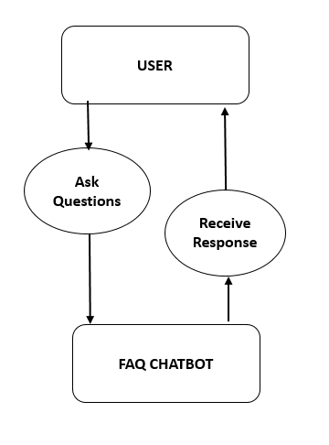

**USE CASE DIAGRAM**

**3.2.2 Class Diagram**

Class diagram consists of classes, interfaces, associations and collaborations. It is representing the object orientation of a system. Hence, it is generally used for development purpose. It is used at time of system construction.

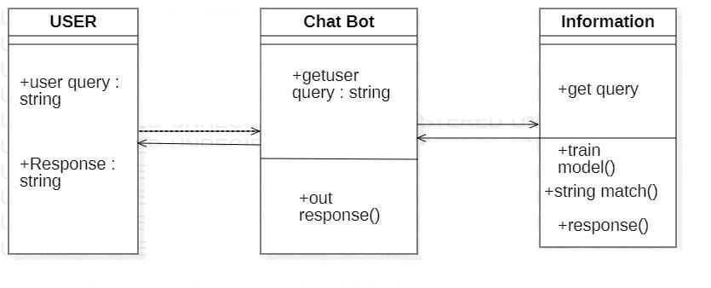

**CLASS DIAGRAM**

**3.2.3 SEQUENCE DIAGRAM:**

A sequence diagram in Unified Modelling Language (UML) is a kind of interaction diagram that shows how processes operate with one another and in what order. It is a construct of a Message Sequence Chart. Sequence diagrams are sometimes called event diagrams, event scenarios, and timing diagrams.

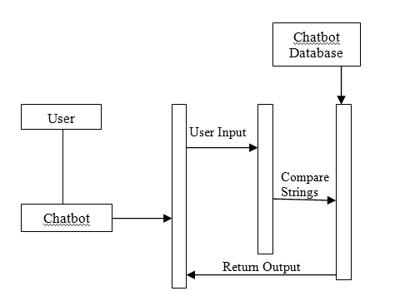

**SEQUENCE DIAGRAM**

**3.2.4 ACTIVITY DIAGRAM**

Activity diagrams are graphical representations of workflows of stepwise activities and actions with support for choice, iteration and concurrency. In the Unified Modelling Language, activity diagrams can be used to describe the business and operational step-by-step workflows of components in a system. An activity diagram shows the overall flow of control.

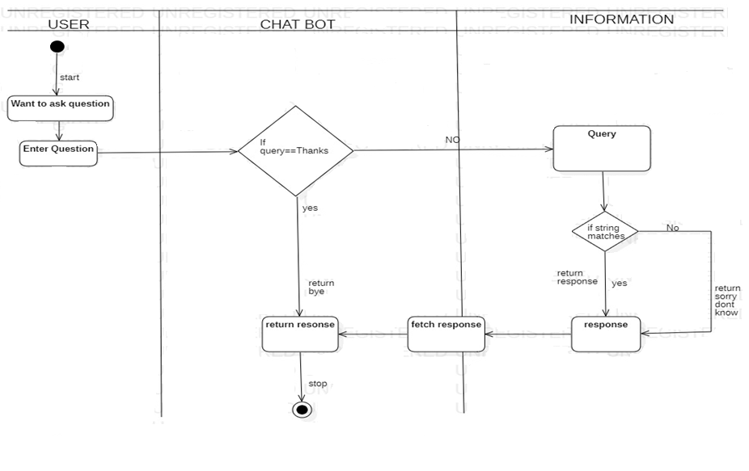

**ACTIVITY DIAGRAM**

SYSTEM DIAGRAM:

A system diagram is a visual model of a system, its components, and their interactions. With supporting documentation, it can capture all the essential information of a system's design. There are many variations of diagramming style that all fall under this rubric.

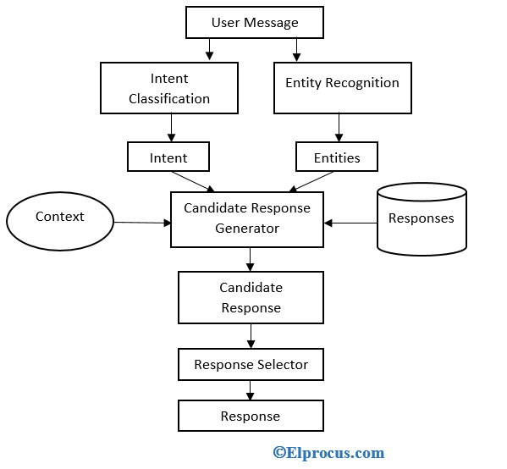

BLOCK DIAGRAM:

A block diagram is a diagram of a system in which the principal parts or functions are represented by blocks connected by lines that show the relationships of the blocks.

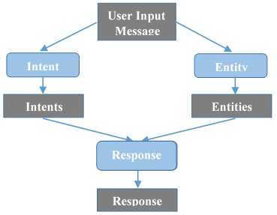

CHAPTER – IV

**SYSTEM IMPLEMENTATION**

**4.1 Language Selection**

**4.1.1 Python**

* Python is an open source programming language that was made to be easy-to read and powerful. A Dutch programmer named Guido van Rossum made python in 1991.
* Python is an interpreted language. Interpreted languages do not need to be compiled to rum. A program called an interpreter runs python code on almost any kind of computer. This means that a programmer can change the code and quickly see the results. This also means Python is slower than a compiled language like C, because it is not running machine code directly.
* Python is a good programming language for beginners. It is a high-level language, which means a programmer can focus on what to do instead of how to do it.
* Writing program in python takes less time than in some other language. Python drew inspiration from other programming languages like C, C++, Java, Perl, and Lisp.
* Python has a very easy- to – read syntax. Some of Python’s syntax comes from C, because that is the language that Python was written in. But Python uses whitespace to delimit code, spaces or tabs are used to organize code into groups. This is different from C. In C, there is a semicolon at the end of each line and curly braces ({}) are used to group code. Using whitespace to delimit code makes Python a very easy-to-read language.

**4.1.2 Features and Specifications**

**Python provides lots of features that are Nested below**

**Easy to Learn and Use**

Python is easy to learn and use. It is developer-friendly and high level programming language

**Expressive Language**

Python language is more expressive means that it is more understandable and readable.

**Interpreted Language**

Python is an interpreted language i.e; interpreter executes the code line by line at a time. This makes debugging easy and thus suitable for beginners.

**Cross-platform Language**

Python can run equally on different platforms such as Windows, Linux, Unix and Macintosh etc. So, we can say that Python is a portable language.

**Free and Open Source**

Python language is freely available. The source-code is also available. Therefore, it is open source.

**Object-Oriented Language**

Python supports object oriented language and concepts of classes and objects come into existence.

**Extensible**

It implies that other languages such as C/C++ can be used to compile the code and thus it can be used further in our python code.

**Large Standard Library**

Python has a large and broad library and provides rich set of module and functions for application development

**GUI Programming Support**

Graphical user interfaces can be developed using Python.

**Integrated**

It can be easily integrated with languages like C, C++, JAVA etc.

**4.1.3 Python Libraries**

* Tensorflow
* tflearn
* nltk
* numpy
* pickle

**Tensorflow**

TensorFlow is an open source library for fast numerical computing.

It was created and is maintained by Google and released under the Apache 2.0 open source license. The API is nominally for the Python programming language, although there is access to the underlying C++ API.

Unlike other numerical libraries intended for use in Deep Learning like Theano, TensorFlow was designed for use both in research and development and in production systems, not least [RankBrain in Google search](https://en.wikipedia.org/wiki/RankBrain) and the fun [DeepDream project](https://en.wikipedia.org/wiki/DeepDream).

It can run on single CPU systems, GPUs as well as mobile devices and large scale distributed systems of hundreds of machines.

TensorFlow can be used in a wide variety of programming languages, most notably Python, as well as Javascript, C++, and Java.[[11]](https://en.wikipedia.org/wiki/TensorFlow#cite_note-:13-11) This flexibility lends itself to a range of applications in many different sectors.

**Tflearn**

TFlearn is a modular and transparent deep learning library built on top of Tensorflow. It was designed to provide a higher-level API to TensorFlow in order to facilitate and speed-up experimentations, while remaining fully transparent and compatible with it.

TFLearn features include:

* Easy-to-use and understand high-level API for implementing deep neural networks, with tutorial and examples.
* Fast prototyping through highly modular built-in neural network layers, regularizers, optimizers, metrics...
* Full transparency over Tensorflow. All functions are built over tensors and can be used independently of TFLearn.
* Powerful helper functions to train any TensorFlow graph, with support of multiple inputs, outputs and optimizers.
* Easy and beautiful graph visualization, with details about weights, gradients, activations and more...
* Effortless device placement for using multiple CPU/GPU.

**NLTK (Natural Language ToolKit)**

NLTK is a leading platform for building Python programs to work with human language data. It provides easy-to-use interfaces to over 50 corpora and lexical resources such as WordNet, along with a suite of text processing libraries for classification, tokenization, stemming, tagging, parsing, and semantic reasoning, wrapper for industrial-strength NLP libraries, and active discussion forum.

Thanks to a hands-on guide introducing programming fundamentals alongside topics in computational linguistics, plus comprehensive API documentation, MLTK is suitable for linguist, engineers, students, all, NLTK is a free, open source, community-driven project.

NLTK has been called “a wonderful tool for teaching, and working in, computational linguistics using Python,” and “an amazing library to play with natural language.”

[Natural Language Processing with Python](https://www.nltk.org/book/) provides a practical introduction to programming for language processing. Written by the creators of NLTK, it guides the reader through the fundamentals of writing Python programs, working with corpora, categorizing text, analysing linguistic structure, and more. The online version of the book has been updated for Python 3 and NLTK 3.

**Numpy**

Numpy, which stands for Numerical Python is a library consisting of multidimensional array objects and a collection of routines for processing those arrays. Using Numpy, mathematical and logical operations on arrays can be performed.

**Operations using Numpy**

Using Numpy, a developer can perform the following operations

* Mathematical and logical operations on arrays
* Fourier transformations and routines for shape manipulation.
* Operations related to linear algebra. NumPy has in-built unctions for linear algebra and random number generation

**Pickle**

Python pickle module is used for serializing and de-serializing python object structures. The process to converts any kind of python objects (list, dict, etc.) into byte streams (0s and 1s) is called pickling or serialization or flattening or marshalling. We can convert the byte stream (generated through pickling) back into python objects by a process called as unpickling.

Why Pickle? : In real world scenario, the use pickling and unpickling are widespread as they allow us to easily transfer data from one server/system to another and then store it in a file or database.

Precaution: It is advisable not to unpickle data received from an untrusted source as they may pose security threat. However, the pickle module has no way of knowing or raise alarm while pickling malicious data.

Only after importing pickle module we can do pickling and unpickling.

**4.2 Screen Shots**

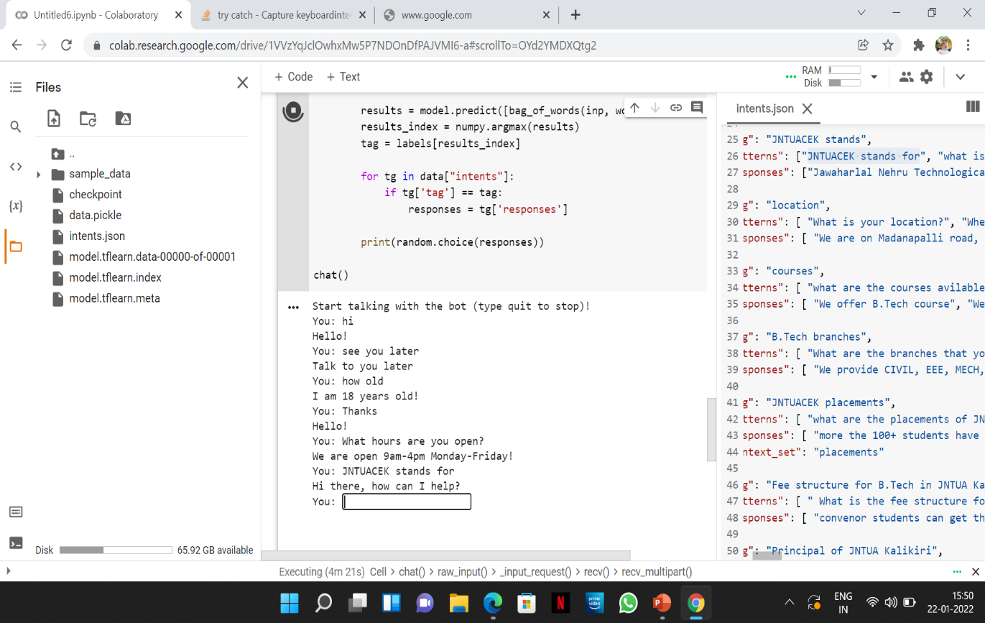

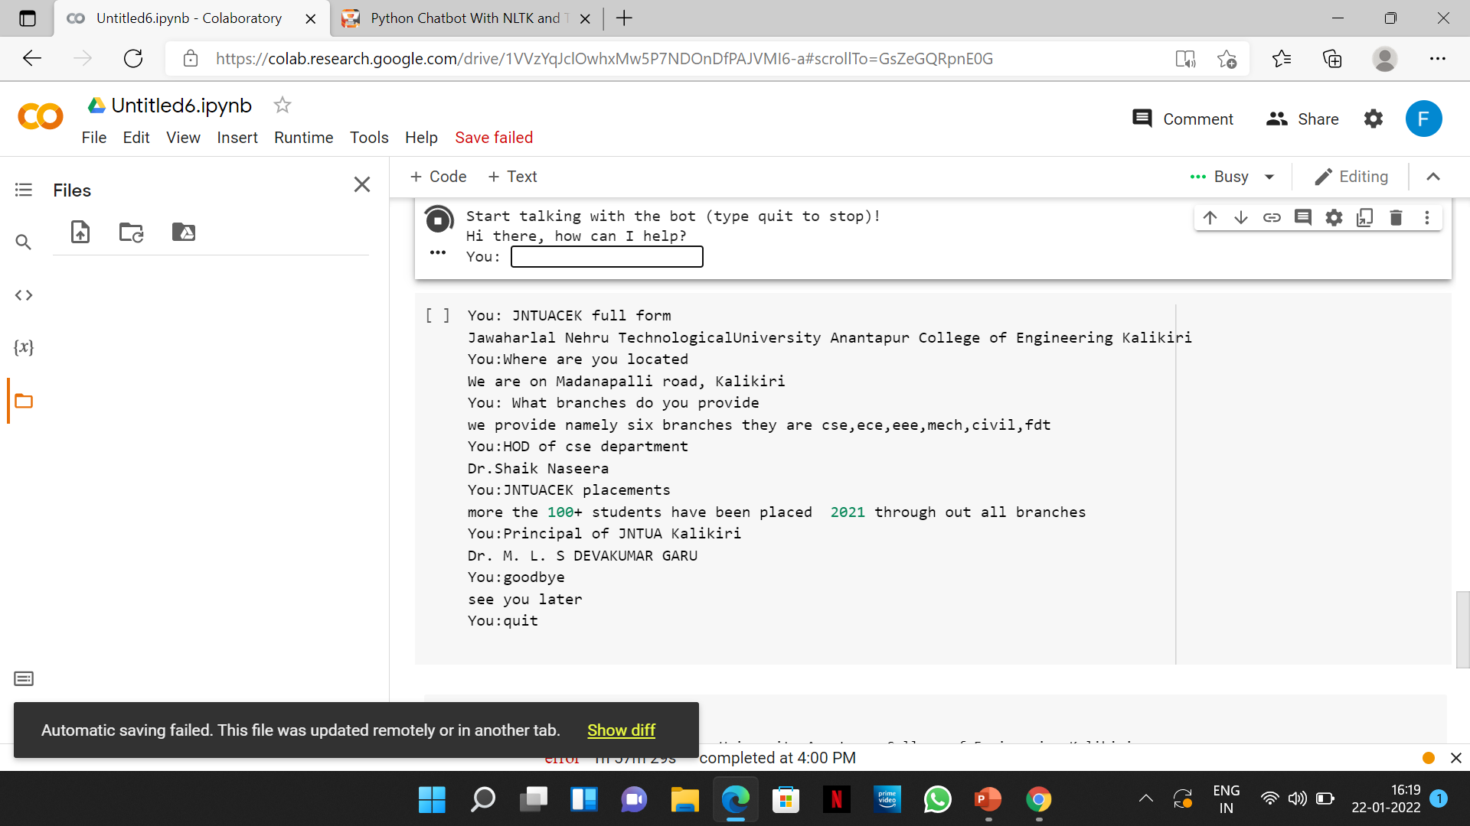

**4.3 Sample Code**

import nltk

from nltk.stem.lancaster import LancasterStemmer

stemmer = LancasterStemmer()

import nltk

nltk.download('punkt')

import numpy

import tensorflow

import random

import json

import pickle

with open("intents.json") as file:

    data = json.load(file)

try:

    with open("data.pickle", "rb") as f:

        words, labels, training, output = pickle.load(f)

except:

    words = []

    labels = []

    docs_x = []

    docs_y = []

    for intent in data["intents"]:

        for pattern in intent["patterns"]:

            wrds = nltk.word_tokenize(pattern)

            words.extend(wrds)

            docs_x.append(wrds)

            docs_y.append(intent["tag"])

        if intent["tag"] not in labels:

            labels.append(intent["tag"])

    words = [stemmer.stem(w.lower()) for w in words if w != "?"]

    words = sorted(list(set(words)))

    labels = sorted(labels)

    training = []

    output = []

    out_empty = [0 for _ in range(len(labels))]

    for x, doc in enumerate(docs_x):

        bag = []

        wrds = [stemmer.stem(w.lower()) for w in doc]

        for w in words:

            if w in wrds:

                bag.append(1)

            else:

                bag.append(0)

        output_row = out_empty[:]

        output_row[labels.index(docs_y[x])] = 1

        training.append(bag)

        output.append(output_row)

    training = numpy.array(training)

    output = numpy.array(output)

    with open("data.pickle", "wb") as f:

        pickle.dump((words, labels, training, output), f)

!pip install tflearn

import tflearn

from tensorflow.python.framework import ops

ops.reset_default_graph()

ops.reset_default_graph()

net = tflearn.input_data(shape=[None, len(training[0])])

net = tflearn.fully_connected(net, 8)

net = tflearn.fully_connected(net, 8)

net = tflearn.fully_connected(net, len(output[0]), activation="softmax")

net = tflearn.regression(net)

model = tflearn.DNN(net)

try:

  model.load("model.tflearn")

except:

  model.fit(training, output, n_epoch=1000, batch_size=8, show_metric=True)

  model.save("model.tflearn")

import matplotlib.pyplot as plt

model.fit(training, output, n_epoch=500, batch_size=8, show_metric=True)

model.save("model.tflearn")

left_coordinates=[1,2,3,4,5]

heights=[0.10,0.30,0.60,0.90,1.00]

bar_labels=['100','200','300','400','500']

plt.bar(left_coordinates,heights,tick_label=bar_labels,width=0.6,color=['red','black'])

plt.xlabel('epoch')

plt.ylabel('accuracy')

plt.title("Accuracy high at 500 epoch")

plt.show()

from nltk import text

from sklearn.metrics import confusion_matrix,accuracy_score

accuracy_score(y_test,y_pred)

def bag_of_words(s, words):

    bag = [0 for _ in range(len(words))]

    s_words = nltk.word_tokenize(s)

    s_words = [stemmer.stem(word.lower()) for word in s_words]

    for se in s_words:

        for i, w in enumerate(words):

            if w == se:

                bag[i] = 1

    return numpy.array(bag)

def chat():

    print("Start talking with the bot (type quit to stop)!")

    while True:

        inp = input("You: ")

        if inp.lower() == "quit":

            break

        results = model.predict([bag_of_words(inp, words)])

        results_index = numpy.argmax(results)

        tag = labels[results_index]

        for tg in data["intents"]:

            if tg['tag'] == tag:

                responses = tg['responses']

        print(random.choice(responses))

chat()

**4.3.1 JSON File:**

{

"intents": [

{

"tag": "greeting",

"patterns": [ "Hi", "How are you", "Is anyone there?", "Hello", "Good day","hey" ],

"responses": [ "Hello, thanks for visiting", "Good to see you again", "Hi there, how can I help?","hey hi" ],

"context set": ""

},

{

"tag": "goodbye",

"patterns": [ "Bye", "See you later", "Goodbye" ],

"responses": [ "See you later, thanks for visiting", "Have a nice day", "Bye! Come back again soon." ]

},

{

"tag": "thanks",

"patterns": [ "Thanks", "Thank you", "That's helpful" ],

"responses": [ "Happy to help!", "Any time!", "My pleasure" ]

},

{

"tag": "hours",

"patterns": [ "What hours are you open?", "What are your hours?", "When are you open?", "When is the time to contact ?","timings", "At what time do you provide services ?" , "college timings”, “what are the timings of the college ?" ],

"responses": [ "We're open every day from 9AM to 5PM", "Our working hours are 9AM to 5PM every day" ]

},

{

"tag": "JNTUACEK stands",

"patterns": ["JNTUACEK stands for", "what is JNTUACEK","JNTUACEK full form"],

"responses": ["Jawaharlal Nehru Technological University Anantapur College of Engineering Kalikiri"]

},

{

"tag": "location",

"patterns": [ "What is your location?", "Where are you located?", "What is your address?", "Where is college address?", "where is this college?", "location", "How can I contact you?" ],

"responses": [ "We are on Madanapalli road, Kalikiri", "Our college is situated in Kalikiri", "Our location is Madanapalli Road, Kalikiri"]

},

{

"tag": "courses",

"patterns": [ "what are the courses available in JNTUACEK?", "courses in JNTUA Kalikiri", "courses offered in JNTC","courses", "what are courses available in JNTUA Kalikiri?" ],

"responses": [ "We offer B.Tech course", "We provide B.Tech with Dual degree courses also for interested students." ]

},

{

"tag": "B.Tech branches",

"patterns": [ "What are the branches that you provide?", "Which branches do you provide?", "B.Tech branches?”, “branches", "branches of B.Tech in JNTUA Kalikiri?" ],

"responses": [ "We provide CIVIL, EEE, MECH, ECE, CSE, FDT(FOOD TECHNOLOGY)" ,"B.Tech - Civil Engineering B.Tech - Computer Science & Engineering B.Tech - Electronics & Communication Engineering B.Tech - Electrical & Electronics Engineering B.Tech - Mechanical Engineering B.Tech – Food Technology" ]

},

{

"tag": "JNTUACEK placements",

"patterns": [ "what are the placements of JNTUA Kalikiri", "placements”, “How many students have been placed?", "how many companies come for JNTUA Kalikiri?", "what are the placements?" ],

"responses": [ "more the 100+ students have been placed in 2021 through out all branches", "more than 100+ students have been placed in various companies" ],

"context_set": "placements"

},

{

"tag": "working days",

"patterns": ["what are working days?", "working days" ],

"responses" : ["monday to friday"]

},

{

"tag": "Fee structure for B.Tech",

"patterns": [ " What is the fee structure for B. Tech?", "fees","fee","fees for B.Tech?", "what is the fee of B.Tech?", "fees" ],

"responses": [ "convenor students can get the fee reimbursement. and government employee family student have to pay 10000 per year." ]

},

{

"tag": "Principal of JNTUA Kalikiri",

"patterns": [ "who is principal of JNTUA Kalikiri ?", "principal name?","principal" ,"principal name"," name of the principal"],

"responses": [ "Dr. M. L. S DEVAKUMAR GARU" ]

},

{

"tag": "Vice-Principal of JNTUA Kalikiri",

"patterns": [ "who is Vice-principal of JNTUA Kalikiri ?", "Vice-principal name?","vice-principal" ,"vice-principal name"," name of the vice-principal"],

"responses": [ "Dr. C.SUBASH GARU" ]

},

{

"tag" : " CSE lab",

"patterns" : [ "where is CSE lab?", "cse lab","CSE lab","How can I reach CSE lab?", "what is the address of CSE lab?", "what is the location of CSE lab?" ],

"responses" : [ "South-east of academic block", "1st floor CSEdepartment academicblock" ]

},

{

"tag" : " ECE lab",

"patterns" : [ "where is ECE lab?", "How can I reach ECE lab?","ece lab","ECE lab","what is the location of ECE lab?", "what is the address of ECE lab?" ],

"responses" : [ "North-east of academic block","ece department academic block","ECE department" ]

},

{

"tag" : "MECH lab",

"patterns" : [ "where is MECH lab?","mech lab","MECH lab", "How can I reach MECH lab?", "what is the location of MECH lab?", "what is the address of MECH lab?" ],

"responses" : [ "South-west of academic block", "mechanical department academic block","mechanical department" ]

},

{

"tag" : "EEE lab",

"patterns" : [ "where is EEE lab?", "How can I reach EEE lab?","ECE lab","ece lab", "what is the location of EEE lab?", "What is the address of EEE lab?" ],

"responses" : [ "South-west of academic block", "ECE department academic block" ]

},

{

"tag" : "CIVIL lab",

"patterns" : [ "where is CIVIL lab?","CIVIL lab","civil lab", "How can I reach CIVIL lab?", "what is the location of CIVIL lab?", "what is the address of CIVIL lab?" ],

"responses" : [ "South of academic block","CIVIL department academic block" ]

},

{

"tag" : " FDT lab",

"patterns" : [ "where is FDT lab?", "How can I reach FDT lab?", "what is the location of FDT lab?", "what is the address of FDT lab?" ],

"responses" : [ "North-edge of academic block","fdt department academic department" ]

},

{

"tag": "WORKSHOPS",

"patterns": [ "workshops", "WORKSHOPS", "About workshops","workshop location" ],

"response" : ["workshops are common for all first years and for all years of mechanical engineering students","workshops are located on the way to girls hostel and staff quarters"]

},

{

"tag": "HOSTELS AND STAFF QUARTERS",

"patterns": [ "hostel facilities", "hostels", "staff quarters", "Hostels" ],

"response": ["there is hostel availability for both girls and boys with all facilities","staff quarters are there for all the feculty and workers"]

},

{

"tag": " CSE about ",

"patterns": [ "about CSE department ", "CSE department ", "cse", "about cse", "CSE", "what does CSE department include " ],

"responses": [ "Department of Computer science and Engineering was established in the year 2013 with the objective of imparting quality education in the field of Computer science and Engineering for more details visit https://www.jntuacek.ac.in" ]

},

{

"tag": "EEE about",

"patterns": [ "about EEE department", "eee", "eee about", "EEE", "EEE about", "tell me about eee department" ],

"responses": [ "Department of Electrical and Electronics Engineering was established in the year 2013 with the objective of imparting quality education in the field of Electrical and Electronics Engineering. for more details visit https://www.jntuacek.ac.in" ]

},

{

"tag": "ECE about",

"patterns": [ "about ECE department", "ece", "ece about", "ECE", "ECE about", "tell me about ece department" ],

"responses": [ "Department of Electronics and Communications Engineering was established in the year 2013 with the objective of imparting quality education in the field of Electronics and Communications Engineering. for more details visit https://www.jntuacek.ac.in" ]

},

{

"tag": "CIVIL about",

"patterns": [ "about CIVIL department", "CIVIL", "civil about", "civil", "about civil", "tell me about civil department" ],

"responses": ["Department of Civil Engineering was established in the year 2013 with the objective of imparting quality education in the field of Civil Engineering. for more details visit https://www.jntuacek.ac.in" ]

},

{

"tag": "MECHANICAL about",

"patterns": [ "about MECHANICAL department", "MECHANICAL", "mechanical", "about mechanical", "mechanical about", "tell me about mechanical department","MECH","mech" ],

"responses": ["Department of Mechanical Engineering was established in the year 2013 with the objective of imparting quality education in the field of Mechanical Engineering. for more details visit https://www.jntuacek.ac.in" ]

},

{

"tag": "FOOD TECHNOLOGY about",

"patterns": [ "about FDT department", "ft", "FT", "fdt", "FDT", "about FT department", "about fdt", "about FDT", "about ft", "about FT", "tell me about food technology department" ],

"responses": [ "Department of FOOD TECHNOLOGY was established in the year 2018 with the objective of imparting quality education in the field of FOOD TECHNOLOGY. for more details visit https://www.jntuacek.ac.in" ]

},

{

"tag": "PHYSICS DEPARTMENT AND LAB",

"patterns": [ "physics lab", "where is physics lab", "physics", "PHYSICS"],

"responses": ["Department of physics is common course for first year,and it is mandatory to learn.Physics lab is located at first floor in administration block."]

},

{

"tag": "CHEMISTRY DEPARTMENT AND LAB",

"patterns": [ "chemistry", "CHEMISTRY", "chemistry lab", "chem", "CHEM", "chemistry hod" ],

"responses": [ "Department of chemistry is common course for first year,and it is mandatory to learn.Chemistry lab is located at first floor in administration block.HOD of this department is DR.N.SARITHA." ]

},

{

"tag": "MATHEMATICS DEPARTMENT",

"patterns": [ "maths", "MATHS", "MATHS DEPARTMENT", "maths department" ],

"responses": ["Department of mathematics is common course upto second year."]

},

{

"tag": "ENGLISH DEPARTMENT AND ENGLISH LAB",

"patterns": [ "english", "ENGLISH", "communication lab", "communication skills department", "communication skills", "english hod" ],

"responses": ["Department of English is common for all the first year and third year students.HOD of the department is Ms.Vimala.V"]

},

{

"tag": "HUMANITIES AND SOCIAL SCIENCE",

"patterns": [ "Humanities", "HUMANITIES", "humanities", "Humanities HOD", "humanities hod" ],

"responses": [ "Department of humanities and social science is common for all students in every year.HOD of humanities and social science is Dr.N.SARITHA" ]

},

{

"tag": "ANTI RAGGING",

"patterns": [ "anti ragging committee", "anti ragging", "ANTI RAGGING", "RAGGING", "ragging","head of anti ragging","HEAD OF ANTI RAGGING","anti ragging squad","ANTI RAGGING SQUAD"],

"responses": ["ANTI RAGGING COMMITTEE head is Dr.N.SARITHA","Ragging is strictly prohibited in JNTUACEK,if at all anyone is encouraged they would be suspended."]

},

{

"tag": "NSS",

"patterns": [ "NSS", "nss", "NSS programs", "nss programs","head of NSS" ],

"response": ["lot of programs are being held under NSS programs like: yoga, cleaning, helping society, martial arts,etc","Head of NSS is Mr. Rajendra Prasad Garu"]

},

{

"tag": "ABOUT COLLEGE",

"patterns": [ "about COLLEGE", "about college auditorium", "AUDITORIUM", "where is auditorium", "auditorium", "Canteen", "where is canteen", "seminar halls", "ground", "indoor stadium" ],

"responses": [ "visit https://www.jntuacek.ac.in/ to know more details about college " ]

},

{

"tag": "library timings",

"patterns": [ "library opening hours", "library hours", "opening hours for library", "library timings" ],

"responses": [ " The library is kept open all working days from 10:00 AM TO 5:30 PM" ]

},

{

"tag": "OFFICES",

"patterns": [ "hostel office", "Hostel office", "examination section", "College office", "college office", "Examination section" ],

"responses": ["all offices are at administration block"]

},

{

"tag": "ADMISSIONS",

"patterns": [ "admission process", "admissions", "Admissions", "Admission process", "lateral entry admissions" ],

"responses": [ "only the students who qualified in AP EAPCET will get admission in college and there is no management seats", "there is only 66 seats available for each branch", "there is only 12 seats available for lateral entry studendts in each branch" ]

},

{

"tag": "GAMES AND SPORTS",

"patterns": [ "Games", "games", "sports", "Sports", "Extra-curricular activities", "extracurricular activities" ],

"responses": ["lot of games and sports are being conducting for every function or program in college and also PET'S staff for both girls and boys separately”, “there is indoor stadium and ground for both girls and boys to play everyday"]

},

{

"tag": " EEE hod",

"patterns": [ "Who is EEE hod?", "EEE hod name?", "name of EEE hod?", "EEE hod", "eee hod" ],

"responses": [ "Prof. M. VENKATESWARA ROA" ]

},

{

"tag": " library ",

"patterns": [ "where is library?", "library?", "library", " tell me about library" ],

"responses": [ "there is library in jntuacek","The central library of this institute fulfilling the academic requirements of user community. It is housed in a three stair separate building with a built-up area of 2134 Sq.", "Stock area fulfilled with text books of all Engineering and Basic Sciencesin which available book collection in stack area is 7666"]

},

{

"tag": "ECE hod",

"patterns": [ "Who is ECE hod?", "ECE hod name?", "name of ECE hod?", "ece hod", "ECE hod" ],

"responses": [ "Dr. C. SUBHAS" ]

},

{

"tag": "MECH hod",

"patterns": [ "Who is MECH hod?", "MECH hod name?", "name of MECH hod?", "MECH hod", "mech hod" ],

"responses": [ "Dr.V. NAGA PRASAD NAIDU " ]

},

{

"tag": " CIVIL hod",

"patterns": [ "Who is CIVIL hod?", "CIVIL hod name?", "name of CIVIL hod?", "CIVIL hod", "civil hod" ],

"responses": [ "Dr. D. NEERAJA" ]

},

{

"tag": "CSE hod",

"patterns": [ "Who is CSE hod?", "CSE hod name?", "name of CSE hod?", "cse hod", "CSE hod" ],

"responses": [ "Dr. SHAIK NASEERA" ]

}]}

**CHAPTER – V**

**SYSTEM TESTING**

**5.1 Testing Description**

The purpose of testing is to discover errors. Testing is the process of trying to discover every conceivable fault or weakness in a work product. It provides a way to check the functionality of components, sub assemblies, assemblies and/or a finished product It is the process of exercising software with the intent of ensuring that the Software system meets its requirements and user expectations and does not fail in an unacceptable manner. There are various types of test. Each test type addresses a specific testing requirement.

**TYPES OF TESTS**

**5.1.1 Unit testing**

Unit testing involves the design of test cases that validate that the internal program logic is functioning properly, and that program inputs produce valid outputs. All decision branches and internal code flow should be validated. It is the testing of individual software units of the application .it is done after the completion of an individual unit before integration. This is a structural testing, that relies on knowledge of its construction and is invasive. Unit tests perform basic tests at component level and test a specific business process, application, and/or system configuration. Unit tests ensure that each unique path of a business process performs accurately to the documented specifications and contains clearly defined inputs and expected results.

**5.1.2 Integration testing**

Integration tests are designed to test integrated software components to determine if they actually run as one program. Testing is event driven and is more concerned with the basic outcome of screens or fields. Integration tests demonstrate that although the components were individually satisfaction, as shown by successfully unit testing, the combination of components is correct and consistent. Integration testing is specifically aimed at exposing the problems that arise from the combination of components.

**5.1.3 Functional test**

Functional tests provide systematic demonstrations that functions tested are available as specified by the business and technical requirements, system documentation, and user manuals. Functional testing is centered on the following items: Valid Input : identified classes of valid input must be accepted. Invalid Input : identified classes of invalid input must be rejected. Functions : identified functions must be exercised. Output : identified classes of application outputs must be exercised. Systems/Procedures: interfacing systems or procedures must be invoked. Organization and preparation of functional tests is focused on requirements, key functions, or special test cases. In addition, systematic coverage pertaining to identify Business process flows; data fields, predefined processes, and successive processes must be considered for testing. Before functional testing is complete, additional tests are identified and the effective value of current tests is determined.

**5.1.4 System Test**

System testing ensures that the entire integrated software system meets requirements. It tests a configuration to ensure known and predictable results. An example of system testing is the configuration oriented system integration test. System testing is based on process descriptions and flows, emphasizing pre-driven process links and integration points.

**5.1.5 Test objectives**

• All questions about the college should be answered.

• Conversation should end if the user say bye.

**5.1.6 Features to be tested**

• Verify that all questions are answered

• Verify that the answer is related to the query

**Test Results:** All the test cases mentioned above passed successfully. No defects encountered.

**5.2 Test Cases**

|  |  |  |  |
| --- | --- | --- | --- |
| **S.No** | **Input** | **Description** | **Test Case Result** |
| 1 | Query about the college | System return answer to the query | Pass |
| 2 | Bye or good bye or thank you | End of the conversation. Chartbot terminated saying bye | Pass |

Table 5.2.1 Sample Test Cases

**Test Results**: All the test cases mentioned above passed successfully. No defects encountered

**CHAPTER – VI**

**CONCLUSION**

**6.1 Conclusion**

In this project, we have introduced a chatbot that is able to interact with users. This chatbot can answer queries in the textual user input. For this purpose, built in tensorflow, tflearn libraries and NLP, Neural Network Concepts are used.We feed the machine with json file which has the question patterns and respective answers. It can answer the questions asked by the user. The questions could be about college details.

**6.2 Future Enrichment**

* Get rid of lazy typing
* By introducing the speech recognition system, can be able to get the information through audio.
* Get reliable and satisfied answers in the multiple spoken languages.
* Integrate real time chat and answer fetching directly from google using AI to be more specific on user query.

**CHECKING ALGORITHMS ACCURACY:**

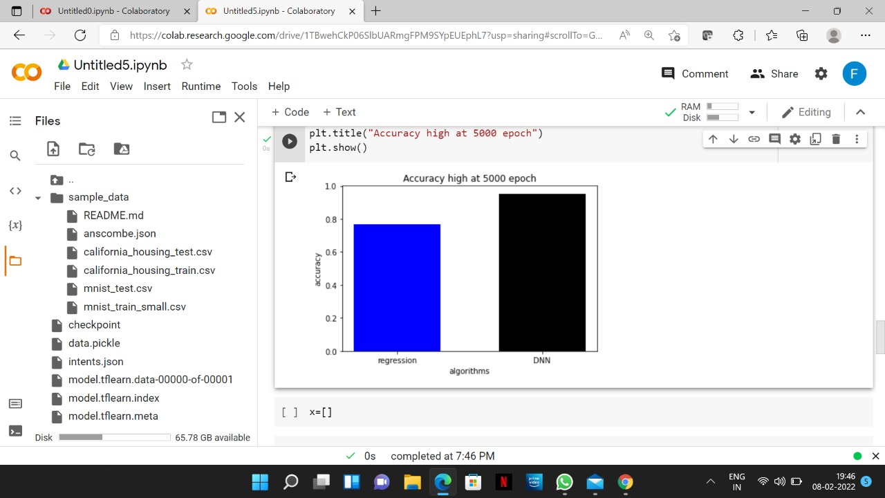

**REACHING CONSTANT ACCURACY:**

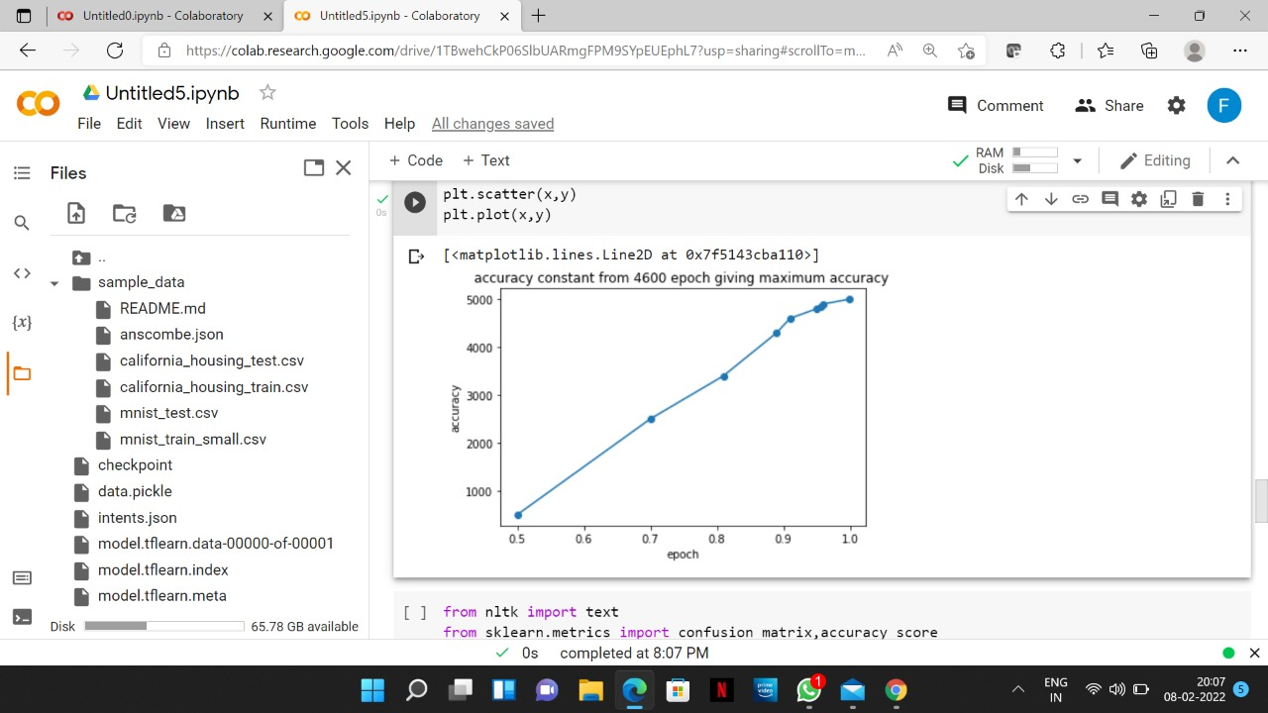

**REFERENCES**

[1] Bayan Abu Shawar and Eric Atwell, 2007 “Chatbots: Are they Really Useful?”

[2] LDV Forum - GLDV Journal for Computational Linguistics and Language Technology.

[3] <http://naaccr1.mkce.ac.in/1.3.4.38.pdf>

[4] [http://www.ldv-forum.org/2007_Heft1/Bayan_AbuShawar _and_Eric_Atwell.pdf](http://www.ldv-forum.org/2007_Heft1/Bayan_AbuShawar%20_and_Eric_Atwell.pdf)

[5] <https://dzone.com/articles/python-chatbot-project-build-your-first-python-pro>

[6] <https://www.analyticsvidhya.com/blog/2021/07/build-a-simple-chatbot-using-python-and-nltk/>

[7] Bringing chatbots into education: Towards natural language negotiation of open learner models. Know.- Based Syst. 20, 2 (Mar. 2007), 177-185.

[8] Intelligent Tutoring Systems: Prospects for Guided Practice and Efficient Learning. Whitepaper for the Army's Science of Learning Workshop, Hampton, VA. Aug 1-3, 2006.

[9] <http://en.wikipedia.org/wiki/Chatterbot>

[10] ALICE. 2002. A.L.I.C.E AI Foundation, <http://www.alicebot.org/>

[11] Kumar, M Naveen, PC Linga Chandar, A Venkatesh Prasad, and K Sumangali (2016). “Android based educational Chatbot for visually impaired people”. In: International Conference on Computational Intelligence and Computing Research (ICCIC), 2016 IEEE. IEEE, pp. 1–4.

[12] Ranoliya, Bhavika R, Nidhi Raghuwanshi, and Sanjay Singh (2017). “Chatbot for University Related FAQs”. In: 2017 International Conference on Advances in Computing, Communications and Informatics (ICACCI). Udupi, pp. 1525–1530.